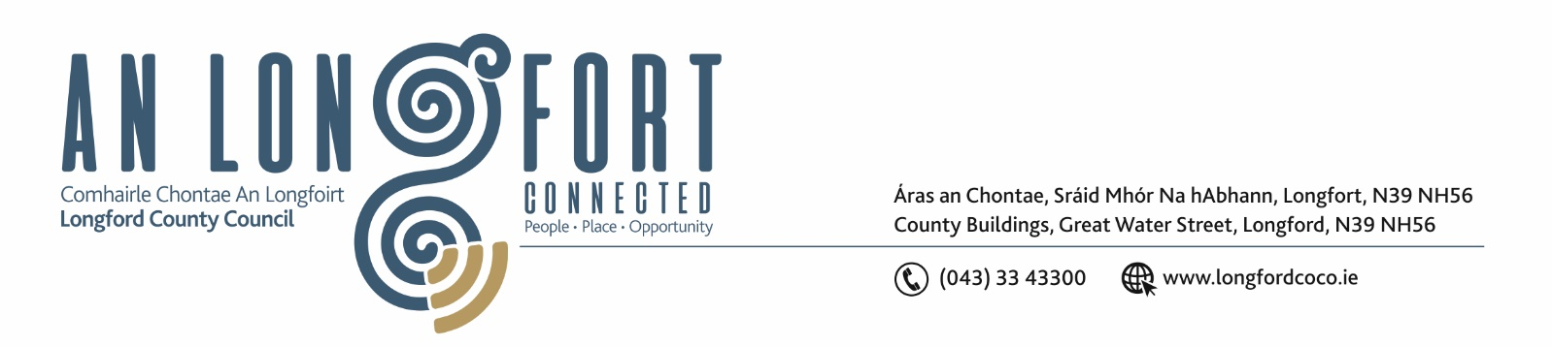

10u Eanair 2019.

Chuig: Gach Ball don Chomhairle.

A Chomhairleoir,

Iarrtar ort bheith i láthair ag Cruinniú Míosuil Chomhairle Chontae Longfoirt a tionólfar i Seomra na Comhairle, Aras an Chontae, Longford ar an Chéadaoin, 16u Eanair 2019 ag 4.00 p.m chun gnó a dhéanamh d’réir an Chláir thíos.

You are requested to attend the Monthly Meeting of Longford County Council to be held in the Council Chamber, Aras an Chontae, Great Water Street, Longford on Wednesday, 16th January 2019 at
4.00 p.m. to transact business, as set out on the Agenda hereunder.

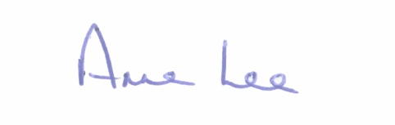
Mise le meas,

__________________
Anne Lee,
Meetings Administrator.

C L A R

- Confirmation of Minutes of the following meetings of Longford County Council –

- Finance Committee Meeting held on the 19th November 2018.
- Budget Meeting held on the 26th November 2018
- Monthly Meeting held on the 12th December 2018.

– copies enclosed.

- Matters arising from Minutes.

- To note Chief Executive Orders - enclosed.

4. To note Monthly Management Report - to follow.

5. To note adopted Minutes of Corporate Policy Group Meeting held on
14th November 2018 - (copy enclosed).

6. Finance & Information Systems.
(a) To note Public Liability Claims received during December 2018 - None.

- To note NOAC 2017 Performance Indicators Report - attached.

(c) Notices of Motions submitted by Councillors, as listed hereunder -

Councillor John Browne.

“ I call on Longford County Council to write to Eoghan Murphy, Minster for Housing, Planning and Local Government, to have the conditions amended under the Rebuilding Ireland Home Loan Application, so as to remove the qualification necessity to be a first buyer.”

7. Housing, Infrastructure, Environment & Emergency Services.

(a) (i) To note adopted Minutes of meeting of Housing Services Strategic Policy Committee held on the 4th September2018 - enclosed.
(ii) To note adopted Minutes of meeting of Infrastructure and Environment Strategic Policy Committee held on the 20th September 2018 - enclosed.

(b) Consideration of disposal of Freehold Interest of No. 3 The Demesne, Longford to
Noel & Anne Gurn in accordance with the terms of Section 183 of the Local Government Act 2001 issued on the 17th December 2018.

(c) Notices of Motions submitted by Councillors, as listed hereunder -

Councillor Seamus Butler.

'That Longford County Council will move to seek framework tenders for the collection of refuse from its tenants, as Limerick Local Authorities have done.'

8. Economic and Community Development, Planning, Human Resources & Corporate Services, Cultural & Recreational Services.

- To note Planning Applications received since December meeting of the Council.

- To note adopted Minutes of meeting of Planning and Development and Cultural Strategic Committee held on the 16th October 2018 - enclosed.

- Consideration and adoption of Revised Polling Scheme - draft previously circulated.

- Modernisation of Electoral Registration Process – Public Consultation.
Documentation enclosed.

- Consideration of Adoption of Part 8 Report (Planning and Development Act 2000 (as amended) and Planning and Development Regulations 2001) (as amended) in respect of the construction of an Industrial Unit at Lisnamuck, IDA Business Park, Ballinalee Road, Longford - details attached.

(f) (i) Political Donations - Local Elections (Disclosure of Donations
and Expenditure ) Act 1999, as amended - Members of Local Authorities.

(ii) Political Donations - Local Elections (Disclosure of Donation
and Expenditure ) Act 1999, as amended - Third Parties.
(Guidelines and form(s) to be circulated )

(g) Notices of Motions submitted by Councillors, as listed hereunder -

Councillor Michael Carrigy.

“I call on Longford County Council to introduce a Shop Front Enhancement grant scheme to help businesses throughout the county. As rate payers, they contribute significant funds to the local authority.”

9. General

- Correspondence – circulated.

Local Authority Elected Members Role and Remuneration Review -
Letter dated 13th December 2017 received from Local Government Oversight and Governance Section, Department of Housing, Planning and Local Government, regarding survey to be completed by members of Local Authorities.

(b) Notices of Motions, submitted by Councillors, as listed hereunder –

Councillor Paul Ross.

“I call on Minister for Agriculture Food and the Marine, Mr. Michael Creed, T.D., to introduce intervention for beef to underpin the beef price from its current non profitable
level .”

10. Votes of sympathy.

11. Training -
Consideration of Report from Corporate Policy Group.



